# LAB BGP:

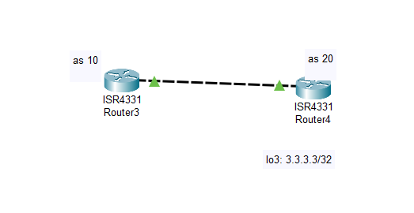

Router3

ROUTER(config)#router bgp 10

ROUTER(config-router)# neighbor 199.99.9.2 remote-as 20

Router4

ROUTER(config)#router bgp 20

ROUTER(config-router)#neighbor 199.99.9.1 remote-as 10

ROUTER(config-router)#network 3.3.3.3 mark 255.255.255.255

# LAB LACP

SWITCH 0:

Switch(config)#int range f0/1-2

Switch(config-if)#channel-group 2 mode active

Switch(config-if)#sw mode trunk

SWITCH 1:

Switch(config)#int range Gig 1/0/1-2

Switch(config-if)#channel-group 2 mode active

Switch(config-if)#sw mode trunk

# LAB 0SPF

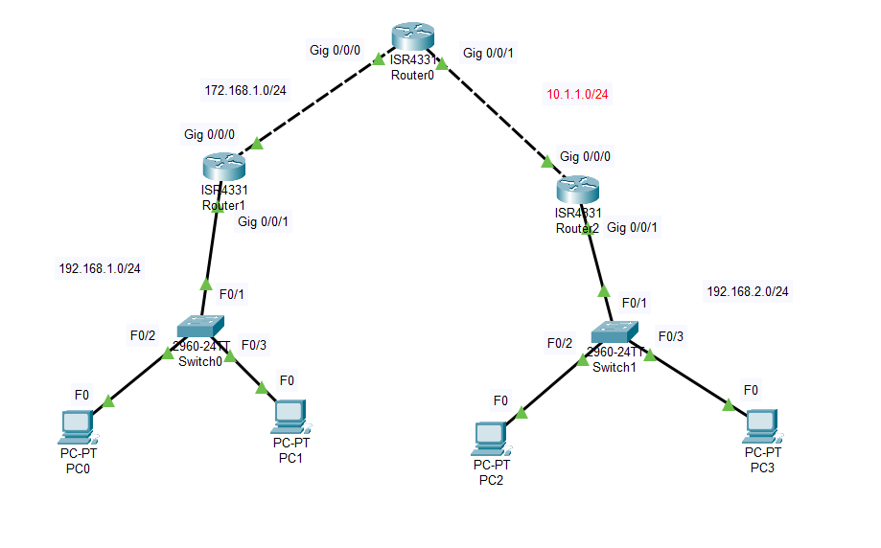

ROUTER 1:

Router(config)#route ospf 1

Router(config-route)#network 192.168.1.0 0.0.0.255 area 0

Router(config-route)#network 172.168.1.0 0.0.0.255 area 0

ROUTER 2:

Router(config)#route ospf 1

Router(config-route)#network 192.168.2.0 0.0.0.255 area 0

Router(config-route)#network 10.1.1.0 0.0.0.255 area 0

ROUTER 0:

Router(config)#route ospf 1

Router(config-route)#network 10.1.1.0 0.0.0.255 area 0

Router(config-route)#network 172.168.1.0 0.0.0.255 area 0

# LAB SUBINTERFACE

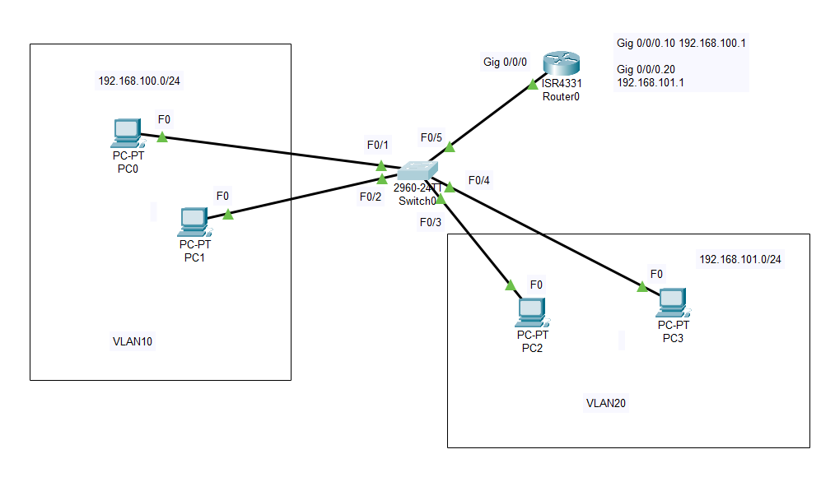

Tạo vlan:

SWITCH(config)#vlan 10

SWITCH(config-vlan)#ex

SWITCH(config)#vlan 20

SWITCH(config-vlan)#ex

Chia vlan cho các cổng:

SW(config)#int f0/1

SW(config-if)#switchport access vlan 10

SW(config-if)#ex

...

SWITCH:

SW(config)#int F0/5

SW(config-if)#sw mode trunk

Router:

ROUTER(config)#int g0/0/0.10

ROUTER(config-subif)#no shut

ROUTER(config-subif)#encapsulation dot1q 10

ROUTER(config-subif)#ip add 192.168.100.1 255.255.255.0

ROUTER(config)#int g0/0/0.20

ROUTER(config-subif)#no shut

ROUTER(config-subif)#encapsulation dot1q 20

ROUTER(config-subif)#ip add 192.168.101.1 255.255.255.0

# LAB ACL

Chia vlan cho cac may:

SW(config)#int F0/1

SW(config-if)#sw access vlan 10

.............

Tao trunk:

SW(config)#int F0/3

SW(config-if)#sw mode trunk

Chia mang con:

Router0(config)#int Gig 0/0/1.10

Router0(config-subif)#no shut

Router0(config-subif)#encapsulation dot1q 10

ROUTER0(config-subif)#ip add 192.168.10.1 255.255.255.0

Router0(config)#int Gig 0/0/1.20

Router0(config-subif)#no shut

Router0(config-subif)#encapsulation dot1q 20

ROUTER0(config-subif)#ip add 192.168.20.1 255.255.255.0

Router0(config)#int Gig 0/0/1.30

Router0(config-subif)#no shut

Router0(config-subif)#encapsulation dot1q 30

ROUTER0(config-subif)#ip add 192.168.30.1 255.255.255.0

Router0(config)#ip route 192.168.20.0 255.255.255.0 192.168.12.2

Router2(config)#ip route 192.168.10.1 255.255.255.0 192.168.12.1

Router2(config)#ip route 192.168.11.1 255.255.255.0 192.168.12.1

*Cấm các IP từ 192.168.10.32 đến 192.168.10.47 của mạng 192.168.10.0/24 đi đến server 192.168.20.2

Router2(config)#access-list 20 deny 192.168.10.32 0.0.0.15

Router2(config)#access-list 20 deny 192.168.11.224 0.0.0.31

Router2(config)#access-list 20 permit any